Hands-on: Create Authentication Service that Returns JWT

Project Structure
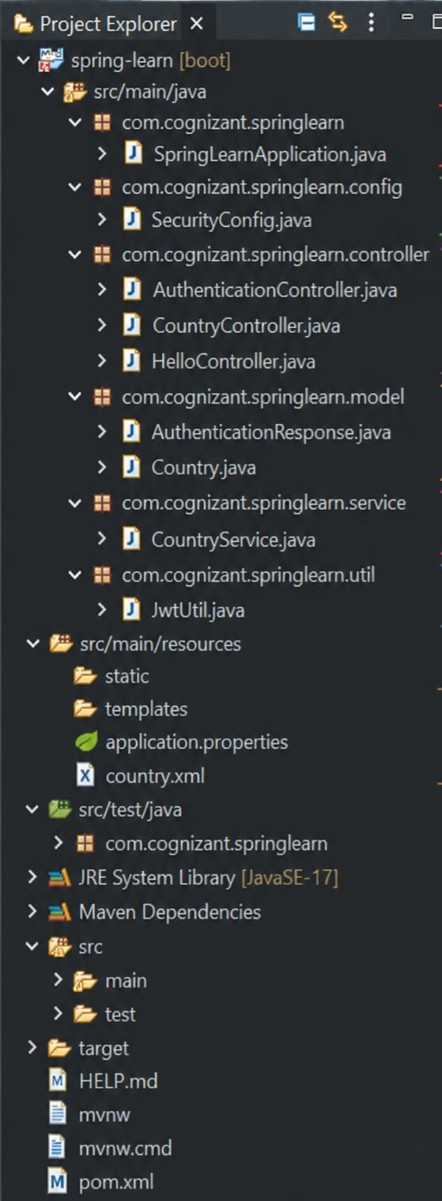

Pom.xml
<?xml version="1.0" encoding="UTF-8"?>
<project xmlns="http://maven.apache.org/POM/4.0.0"
xmlns:xsi="http://www.w3.org/2001/XMLSchema-instance"
xsi:schemaLocation="https://maven.apache.org/POM/4.0.0 https://maven.apache.org/xsd/maven-4.0.0.xsd">
<modelVersion>4.0.0</modelVersion>
<parent>
<groupId>org.springframework.boot</groupId>
<artifactId>spring-boot-starter-parent</artifactId>
<version>3.5.16</version>
<relativePath/>
</parent>
<groupId>com.cognizant</groupId>
<artifactId>orm-learn</artifactId>
<version>0.0.1-SNAPSHOT</version>
<name>orm-learn</name>
<description>Demo project for Spring Data JPA and Hibernate</description>
<properties>
<java.version>17</java.version>
</properties>
<dependencies>
<!-- Spring Data JPA -->
<dependency>
<groupId>org.springframework.boot</groupId>
<artifactId>spring-boot-starter-data-jpa</artifactId>
</dependency>
<!-- MySQL Driver -->
<dependency>
<groupId>com.mysql</groupId>
<artifactId>mysql-connector-j</artifactId>
<scope>runtime</scope>
</dependency>
<!-- DevTools -->
<dependency>
<groupId>org.springframework.boot</groupId>
<artifactId>spring-boot-devtools</artifactId>
<scope>runtime</scope>
<optional>true</optional>
</dependency>
<!-- Testing -->
<dependency>
<groupId>org.springframework.boot</groupId>
<artifactId>spring-boot-starter-test</artifactId>
<scope>test</scope>
</dependency>
</dependencies>
<build>
<plugins>
<plugin>
<groupId>org.springframework.boot</groupId>
<artifactId>spring-boot-maven-plugin</artifactId>
</plugin>
</plugins>
</build>
</project>

AuthenticationResponse.java
package com.cognizant.springlearn.model;
public class AuthenticationResponse {
private String token;
public AuthenticationResponse(){}
public AuthenticationResponse(String token){this.token=token;}
public String getToken(){return token;}
public void setToken(String token){this.token=token;}
}

JwtUtil.java
package com.cognizant.springlearn.util;
import java.security.Key;
import java.util.Date;
import javax.crypto.spec.SecretKeySpec;
import io.jsonwebtoken.*;
public class JwtUtil {
private static final String SECRET="mysecretkeymysecretkeymysecretkey12";
private static final Key KEY=new SecretKeySpec(
SECRET.getBytes(),SignatureAlgorithm.HS256.getJcaName());
public static String generateToken(String username){
return Jwts.builder()
.setSubject(username)
.setIssuedAt(new Date())
.setExpiration(new Date(System.currentTimeMillis()+600000))
.signWith(KEY)
.compact();
}
}

AuthenticationController.java
@RestController
public class AuthenticationController {
@GetMapping("/authenticate")
public AuthenticationResponse authenticate(
@RequestHeader(HttpHeaders.AUTHORIZATION) String authorizationHeader){
String base64Credentials=authorizationHeader.substring(6);
byte[] decodedBytes=Base64.getDecoder().decode(base64Credentials);
String credentials=new String(decodedBytes,StandardCharsets.UTF_8);
String username=credentials.split(":",2)[0];
String token=JwtUtil.generateToken(username);
return new AuthenticationResponse(token);
}
}

SecurityConfig.java
@Configuration
public class SecurityConfig {
@Bean
public InMemoryUserDetailsManager userDetailsService(){
UserDetails user=User.withUsername("user")
.password("{noop}pwd")
.roles("USER")
.build();
return new InMemoryUserDetailsManager(user);
}
@Bean
public SecurityFilterChain securityFilterChain(HttpSecurity http)throws Exception{
http.csrf(csrf->csrf.disable())
.authorizeHttpRequests(auth->auth.requestMatchers("/authenticate").authenticated()
.anyRequest().permitAll())
.httpBasic(Customizer.withDefaults());
return http.build();
}
}

Console Output
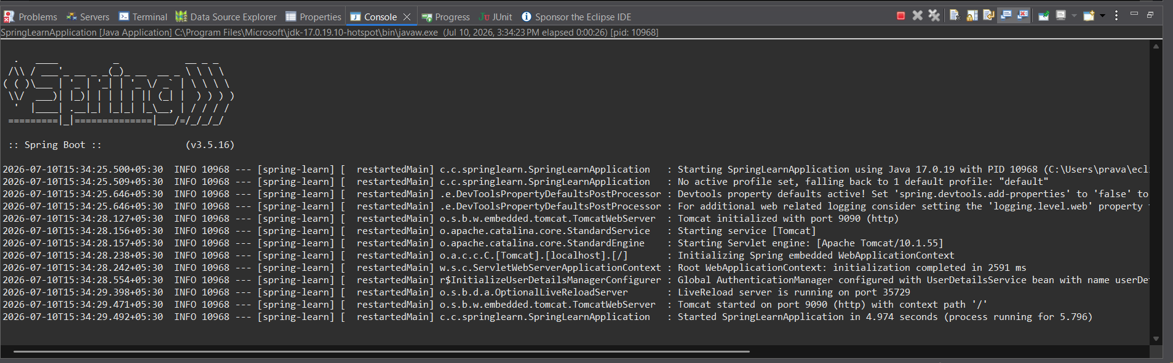

Browser login page for /authenticate
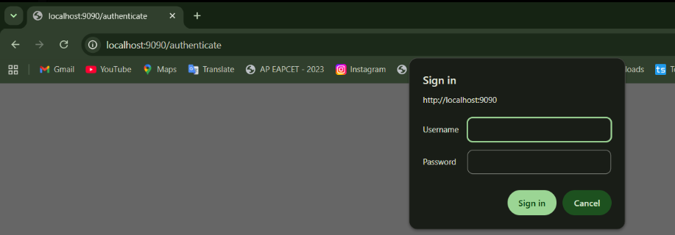

Browser output showing ‘Authentication Service’ (before JWT)
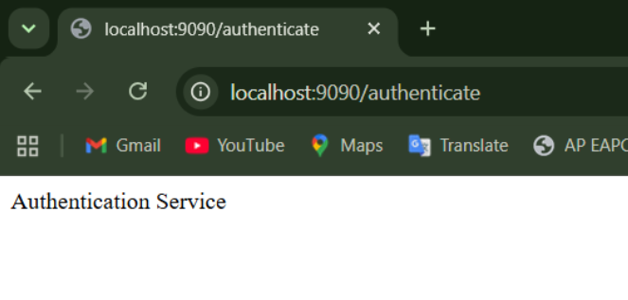

Browser Output after JWT
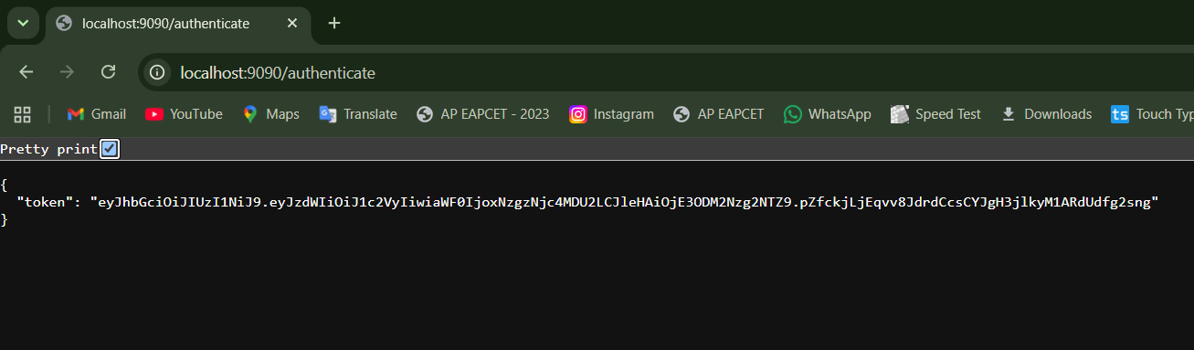

Testing
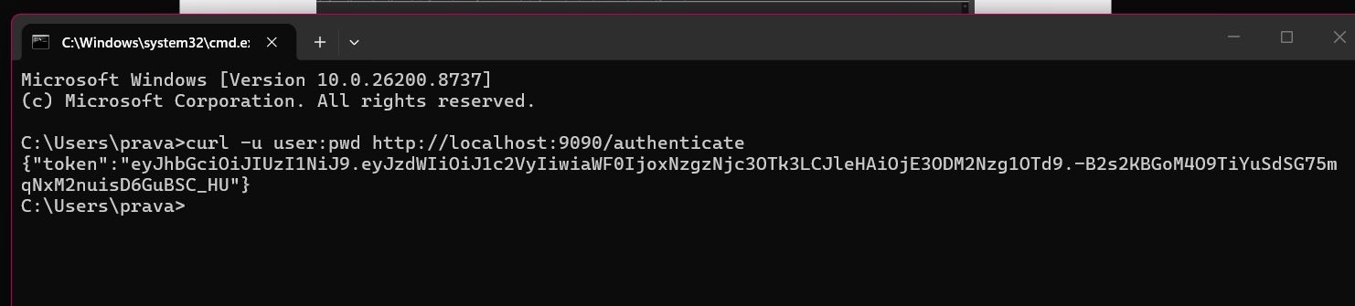

Result
The authentication service was successfully implemented using Spring Security. Basic Authentication credentials were validated and a JWT token was generated and returned successfully.

